Procedures of updating the voice firmware:
1. You need to prepare a USB to serial board, such as CP2102, or CH34 series, and install the driver program. Note that the CN folder in the figure below contains Chinese files, while the EN folder contains English files.
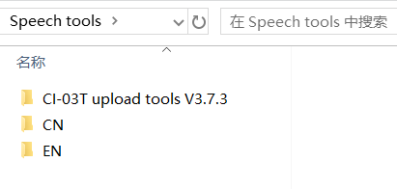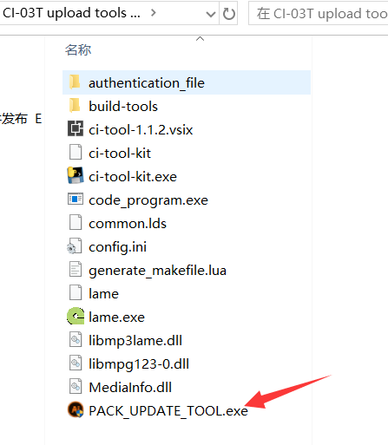
2. Copy the folder in SD card as shown in the picture to your computer and run PACK-UPDATA_TOOL.exe
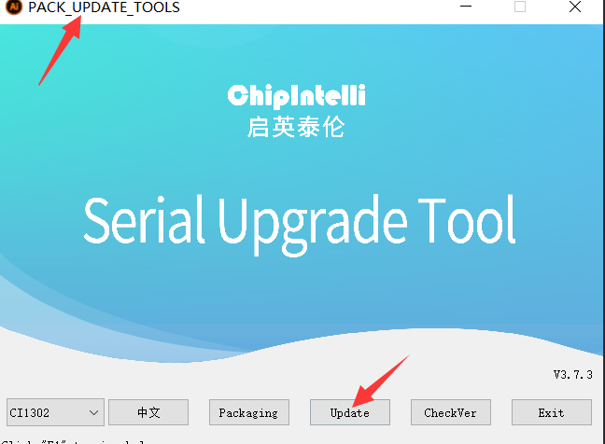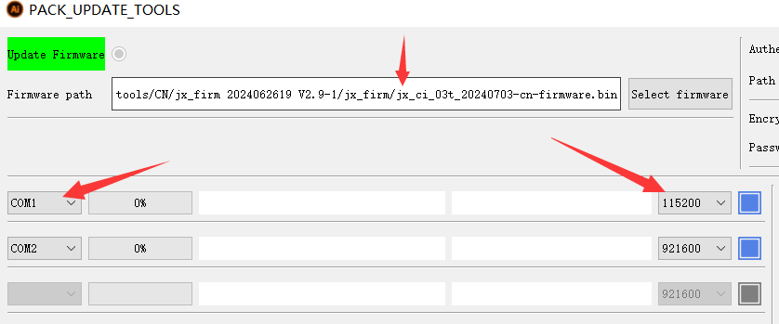
3. Connect the GND, RXD, and TXD of the USB board to 1, 2, and 3 respectively as shown in the figure below
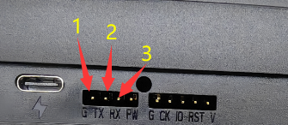
4. Set the radio, following image as below
5. Start the upgrade tool on the computer, as indicated below
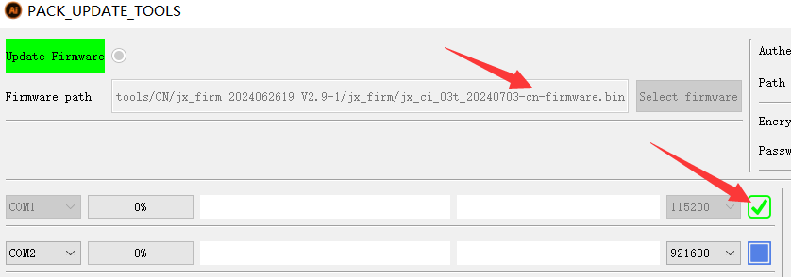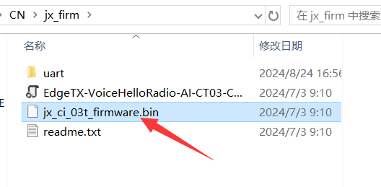
6. Turn on the power switch of the remote control, as shown in the photo below. If there is no problem with the cable connection, you should see the progress bar moving. If it fails, please repeat steps 2-6 above, and the upgrade will be successful.
HelloRadioSky QQ技术交流群：83162463 微信群技术交流群：
https://www.helloradiosky.com

